**Your invitation to join us to organise & celebrate Australia Day 2019**

**@ the Balla Balla Centre in Cranbourne**

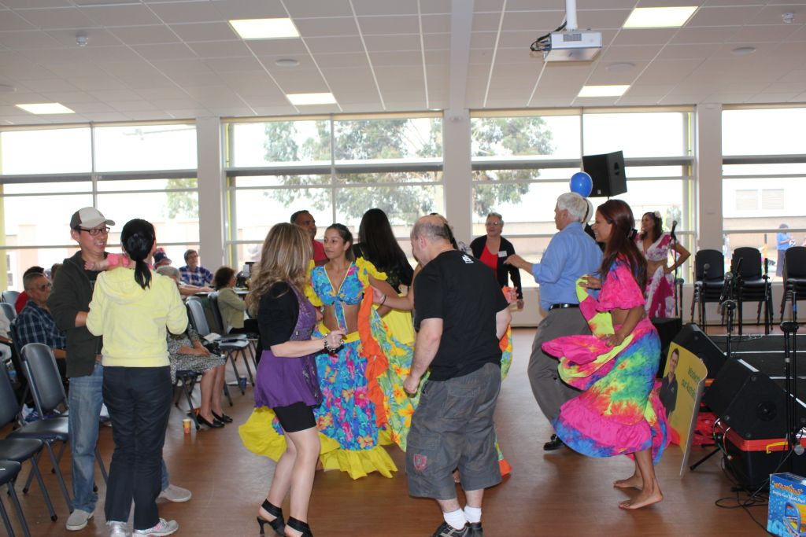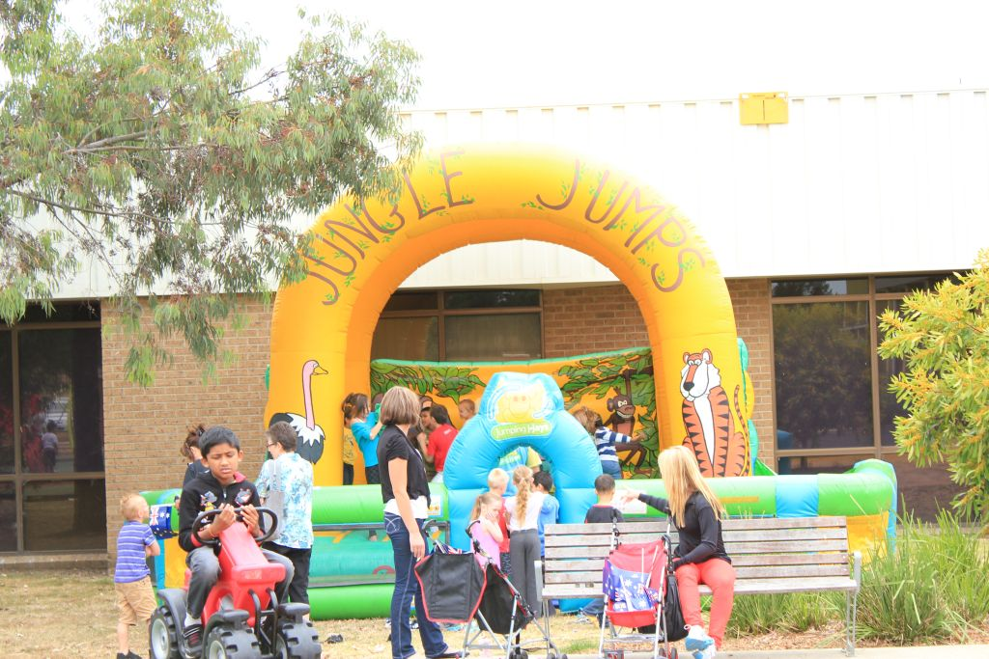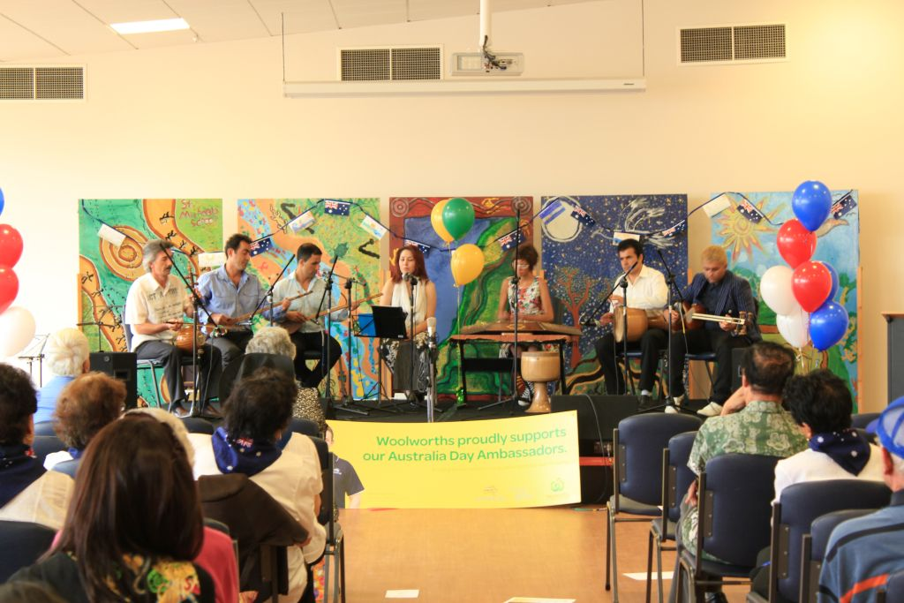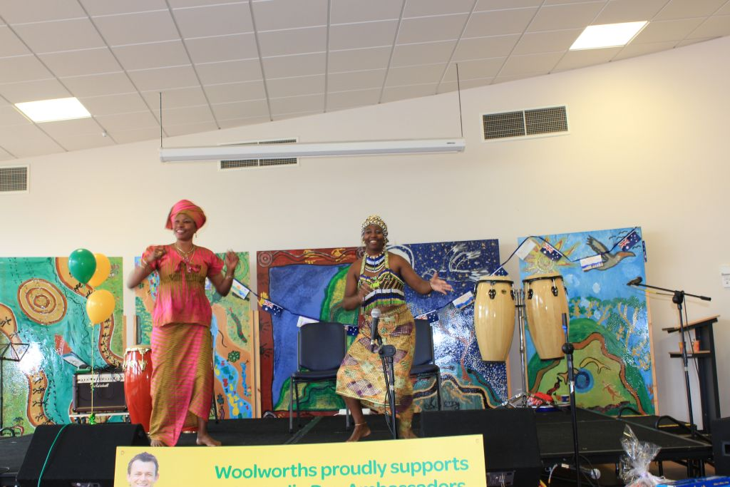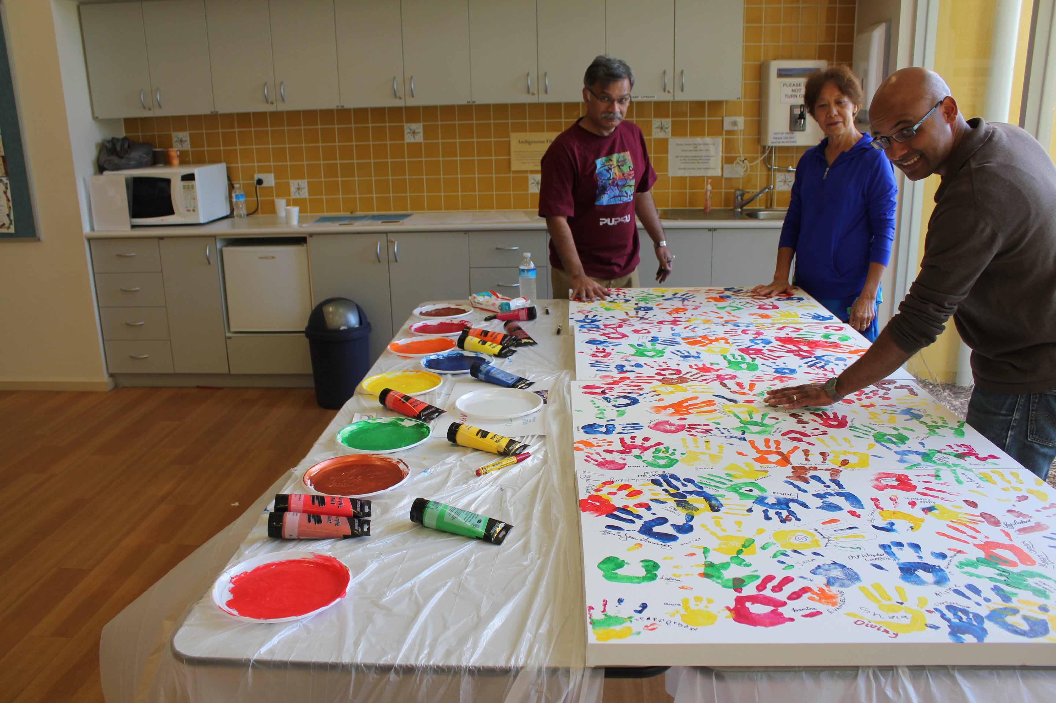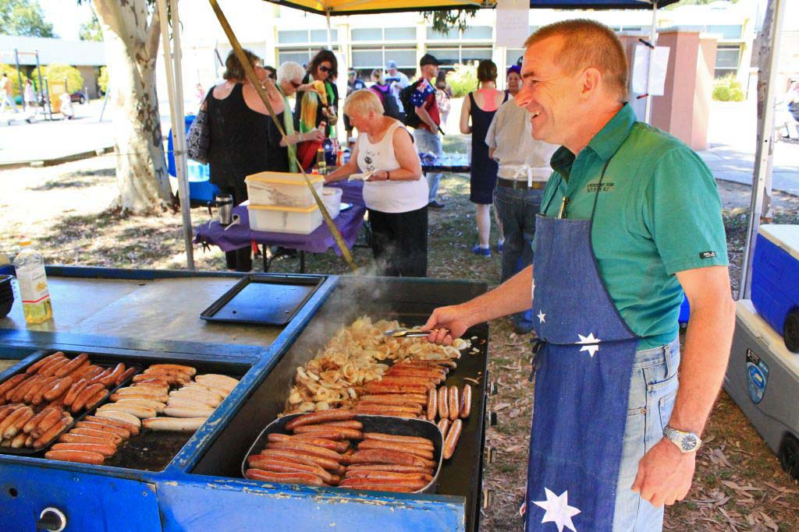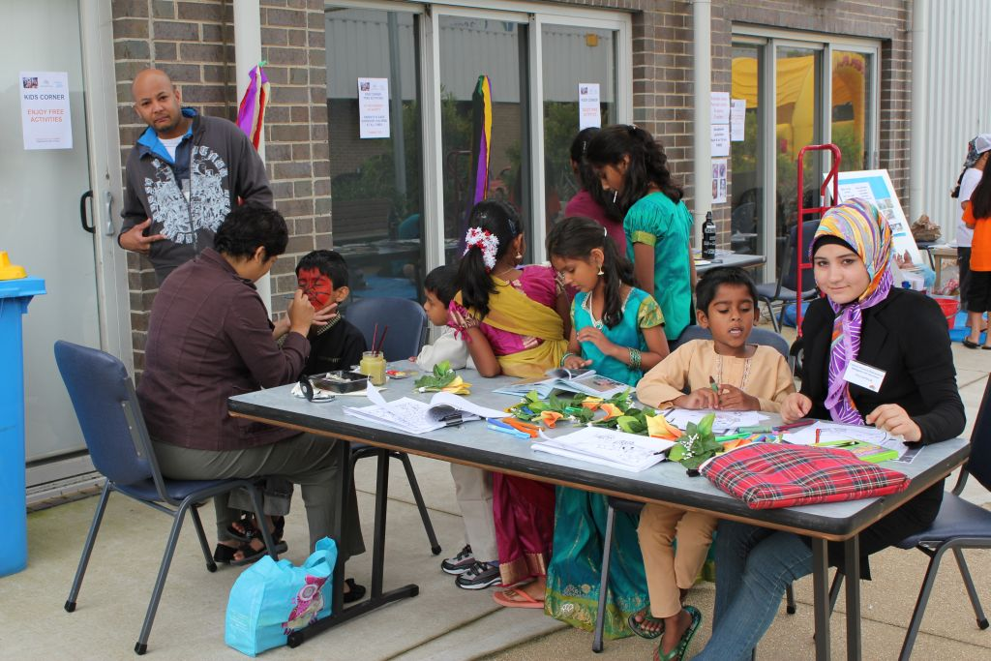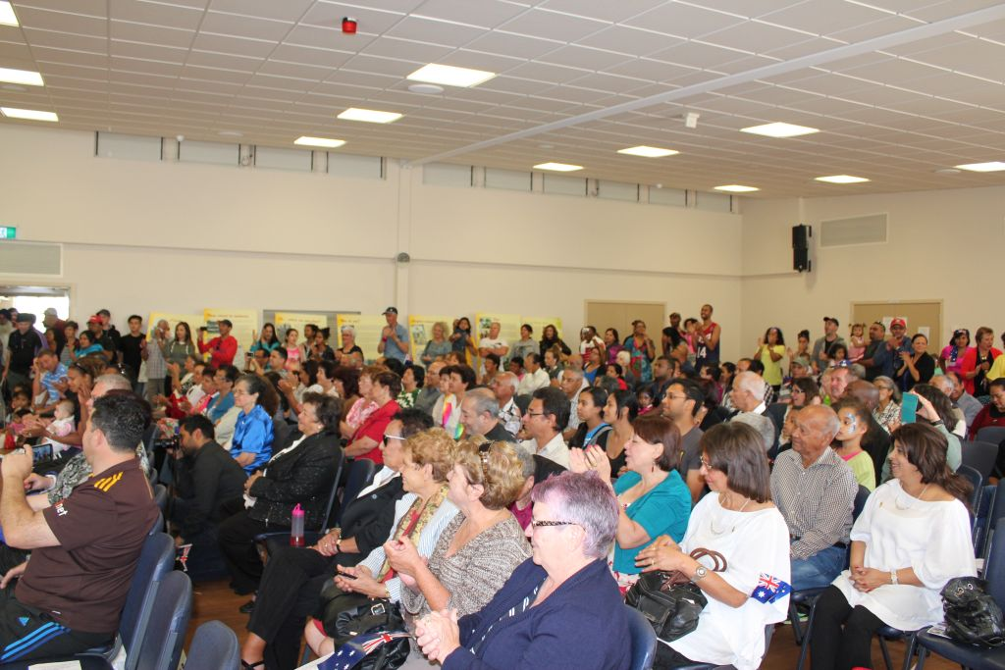

*Photos courtesy of CHARM Vic, Previous Australia Day Celebrations – Cranbourne event*

**This is another great opportunity for all of us to celebrate what makes Casey and our country so wonderful!**

The Cultural Historical Association of Rodriguans & Mauritians in Victoria (C.H.A.R.M Vic) in collaboration with various community groups and individuals will once again host the ***Passport to Casey’s Cultural Heritage Showcase***,

**a FREE family event** **showcasing our rich and diverse cultural heritage and what makes us proud to live in the City of Casey.**

**How can you play a part?**

* **Express your interest to be involved!**

**Contact us by Friday 9 November 2018** if you can **be involved. Volunteer** **your time and/or talent** (dance, sing, paint, drum, cook and more) **and be part of this inclusive community celebration**

* **Save the date now - join us on Saturday 26th January 2019**

**Time:** 11:00 AM - 4:00 PM   
**Address:** Balla Balla Centre, 65 Berwick-Cranbourne Road,

Cranbourne East

**The event will include:**

* a free sausage sizzle
* traditional music/dances, drumming, a cultural exhibition, workshops
* lots of free children’s activities and more.

**For more details:**

Call: Edwige 0418 367 417 or email: [president@charm.org.au](mailto:president@charm.org.au)

Visit [www.charm.org.au](http://www.charm.org.au) for regular updates

**If you need help filling in the forms, please call us.**

**Note that all requests to perform and/or have a stall/display will be subject to the committee’s approval and will need to meet all risk/safety requirements and legal obligations.**

**We aim to have a draft program issued for feedback in Dec 2018. Final event details and program to be confirmed 2 weeks prior to the event or earlier (may be subject to change depending on circumstances beyond our control). The organisers will liaise with key contact regarding the outcome of your expression of interest, any requirements, changes etc.**



**EXPRESSION OF INTEREST (EOI)**

**PERFORMING GROUPS**

1. **General Details**

|  |  |  |  |  |  |  |  |
| --- | --- | --- | --- | --- | --- | --- | --- |
| **Type of group (Please tick):** | | | | | | | |
| Choir or Band | | Dance Group | | | | Theatrical Group | |
| Solo Singer | | Other, please provide details: | | | | | |
| **Performing Group name:** | |  | | | | | |
| **Contact name:** | |  | | | | | |
| **Phone:** |  | | | | | **Mobile:** |  |
| **Email:** |  | | | | | | |
| **Address:** |  | | | | | | |
|  |  | | | | | | |
| **Group or individual Profile/Bio:**    **Description of performance:** | | |  | | | | |
|  | | | | | | | |
| **Duration of your performance  (Please tick):**  **We do our best to accommodate all requests, however as this is a community event and we want to be inclusive in engaging as many as possible, we may not be able to provide the requested timeframe. We will confirm this 3 weeks prior to event date** | | | | **5min  10min**  **15min  Other request:___________** | | | |
| **Number of people performing on the stage:** | | | | | (Maximum of 15) | | |
|  | | | | |  | | |

1. **Sound Requirements**

|  |  |
| --- | --- |
| **Technical requirements** | |
| **Do you require a microphone for your performance:** | **Yes**  **No** | |
| **Number of microphones required:** | **1**  **2** | |
| **Please specify the type of microphone you require:** | **Handheld Wireless**  **Handheld Cord** | |
| **Do you require a CD Player:** | **Yes**  **No** | |
|  |  | |
| **Will live music be part of your performance?** | **Yes**  **No** | |
| If yes, describe the instruments used for this live music: |  | |
| **Are there any other technical requirements you have for your performance:** | | |
|  | | |
| **Do you have any special accessibility requirements to access the stage and/ or event site:** (If so please provide details) | | |
|  | | |

1. **Agreement**

|  |
| --- |
| I have read the information and I agree to comply with the Terms and Conditions and to work closely with the organisers to make this event fun, safe and successful for all.  **Signed**  *(Type full name if completing electronically)*  **Name**  **Group/ Company**  **Date** |

**EXPRESSION OF INTEREST (EOI)**

**STALLHOLDERS/DISPLAY**

1. **General Details**

|  |  |  |  |  |  |  |  |  |
| --- | --- | --- | --- | --- | --- | --- | --- | --- |
| **Type of group (Please tick):** | | | | | | | | |
| Arts/Crafts | | | Collectables | | | Educational | |  |
| Clothing | | | Other, please state: | | |  | | |
| **Group/company name:** | | | |  | | | | |
| **Contact name:** | | | |  | | | | |
| **Phone:** | |  | | | | **Mobile:** |  | |
| **Email:** | |  | | | | | | |
| **Address:** | | **Postcode:** | | | | | | |
| **Description of stall content (please be specific):** | | | | |  | | | |
|  |  | | | | | | | |
|  |  | | | | | | | |
|  |  | | | | | | | |
| **Size you require for your stall in (i.e. 4m wide by 2m deep):**  **Extra equipment requirements (you will be provided with one table and two chairs):** | | | | | | | | |
| **All stalls/display will need to be supervised by your volunteers. We are not responsible for valuable items, so please keep them safe and don’t leave these unsupervised. All equipment must be safety checked and tagged.**  **Whilst we do not charge a set fee for community groups, not for profit businesses and individuals to be involved, a donation towards the event activities and door prizes is appreciated. A small fee may apply for commercial businesses. All expressions of interest will be reviewed by the organising committee and are subject to their final approval. You will be advised by end of November 2018.**  **If you have any questions please contact us.** | | | | | | | | |

1. **Power**

|  |
| --- |
| **Power Points are limited around the perimeter of the hall. Please indicate whether your stall/display requires the use of a power point socket.**  **Yes**  **No** |

1. **Insurance**

|  |
| --- |
| Whilst all care is taken we will not accept any liability for equipment that is lost, stolen or damaged whilst on the event site for the duration of Saturday 26 January 2019.  All stallholders must have current personal/business insurance cover for loss of, damage to and theft of property. |

1. **Agreement**

|  |  |
| --- | --- |
| I/We accept the terms and conditions for this event and will work closely with the organisers to make this event fun, safe and successful. I/we agree to comply with the Terms and Conditions. | |
| **Signed:** |  |
| **Name:** |  |
| **Group/ Company:** |  |
| **Date:** |  |
|  | |

**EXPRESSION OF INTEREST (EOI)**

**EVENT VOLUNTEER**

1. **General Details**

|  |  |  |  |  |  |
| --- | --- | --- | --- | --- | --- |
|  | | | | | |
| **Name:** | |  | | | |
| **Phone:** |  | | | **Mobile:** |  |
| **Email:** |  | | | | |
| **Address:** |  | | | | |
|  |  | | | | |
| **You will be briefed on the day of the event on the standards of behaviour and expectations that form part of the conditions of your volunteer placement. Also please note that it is a legal requirement for Volunteers to have a Working with Children Check.** | | | | | |
| **Time Available  (Please tick):** | | | **9am–11 am  11am–1pm  1pm-3pm  2pm-4pm** | | |

Thank you for your interest



We look forward to your involvement and positive contribution.

Together we can make a difference